ANTI-INTOXICATION CELL
ST. GREGORIOS COLLEGE
KOTTARAKARA

REPORT ON THE ACTIVITIES 2018-2019

Co-ordinator
Dr. SAJEESH S
Assistant Professor
Dept. of English

Report
It is highly important for all academic institutions to be vigilant of any kind of drug peddlers who intrude into the campus premises. We understand that our students are the promise of our future nation. Hence, it is urgent to monitor and counsel young students continuously so that we can guide them through path of mental and physical sobriety. The Anti-addiction Cell of St. Gregorios College is conspicuous and vigilant of any unhealthy tendencies from anyone who by chance bring drugs or alcohol beverages within the campus, or influence the students to use it outside. Moreover, the cell is very earnest in conducting awareness and counselling sessions for our students and the targeted young public.
The Anti-addiction Cell conducted a procession of students on the Anti-addiction day on 26 June 2019. Hundreds of students from the college, both boys and girls participated in the procession. The procession started from the college campus where it was flagged off by the principal, Dr. Suman Alaxander. The procession continued to different parts of Kottarakkara. It was a very successful programme to provide awareness of tragic effects of drugs and drug addiction.
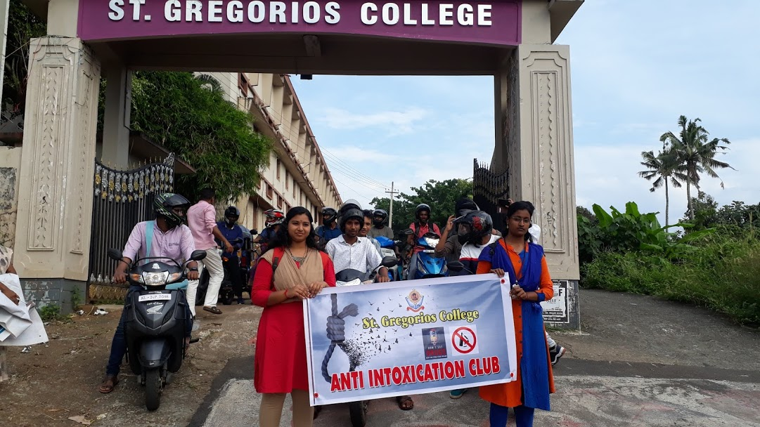
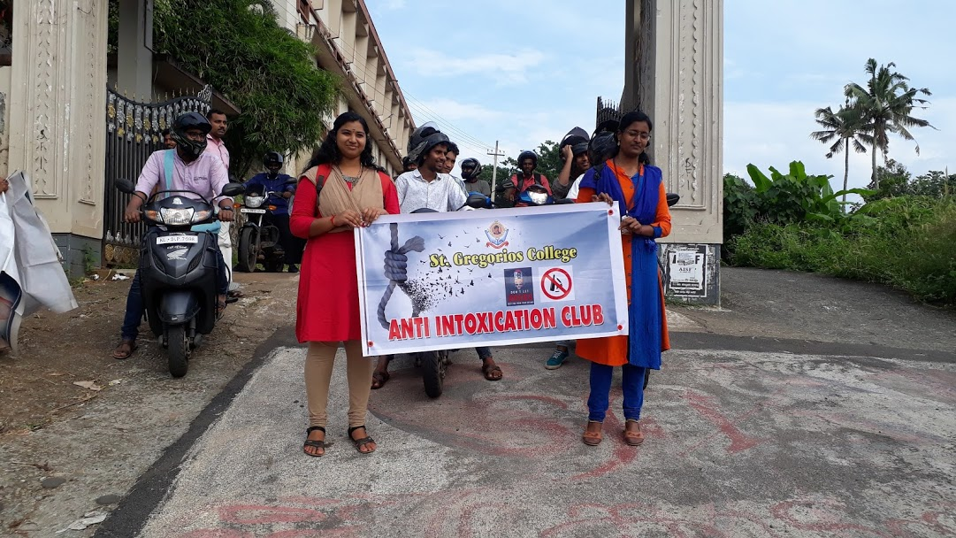
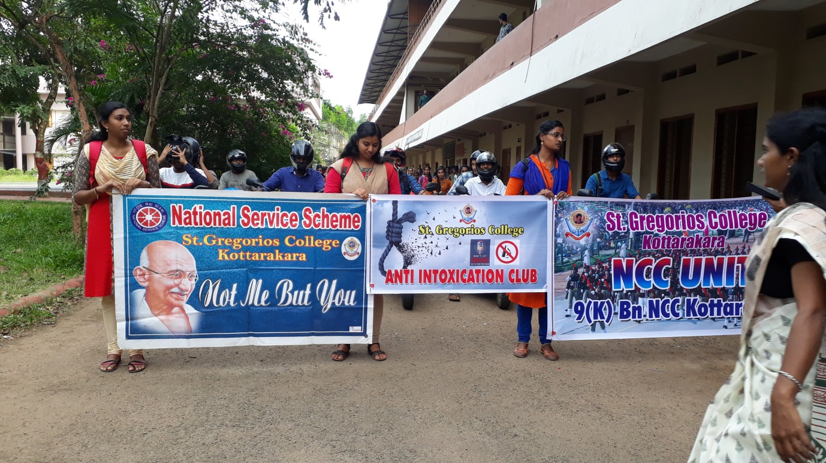

Further, on 31st January 2020 the Anti-addiction Cell along with the JanaMaithri Police Station Kottarakkara, conducted a Safe Campus Campaign against the abuse of drug and alcahol within the campuses. Around 200 students in the college participated in the campaign. Awareness and counselling sessions were conducted by police ane excise officerrs. The key note session was conducted by Mr. Richard, retired Exicice Commisionire. All in all the campaign was a great achievement for the cell.
