ST. GREGORIOS COLLEGE, KOTTARAKARA

REPORT OF HEALTH CLUB DURING THE ACADEMIC YEAR 2019-2020

“Motivation is what gets you started; Habit is what keeps you going”. He who has health has hope, and he who has hope has everything.
- Jim Ryun
The utility of Health Clubs can only be understood through active involvement, which will certainly help in creating a healthy society and leading to responsible citizenship as, healthy people work better and carry forward a progressive nation.
Upholding the above views, the functioning of Health Clubs in tune with present life style is considered to be a mandatory aspect for Colleges. In addition to the regular physical education, a health club is functioning in the college for training the whole students through demonstrations, practices, seminars etc to lead a healthy life.
In the present academic year, only a few activities were conducted due to the tight academic schedule and unexpected termination of academic year which happened as a result of COVID-19 outbreak. However, the activities promoted and various facilities provided for the hygienic environment in the College during the academic year can be summarized under the following heads:
MULTIGYMNASIUM
A Multi Gymnasium is set up in the college with all the necessary equipments so as to help the inmates to progress in physical fitness. The health club monitors the overall functioning of the gymnasium.
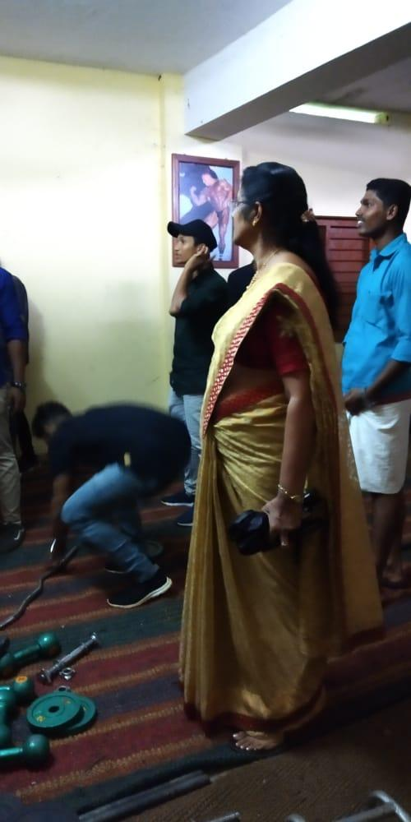
Principal Dr.Suman Alexander monitors the activities of the Gymnasium

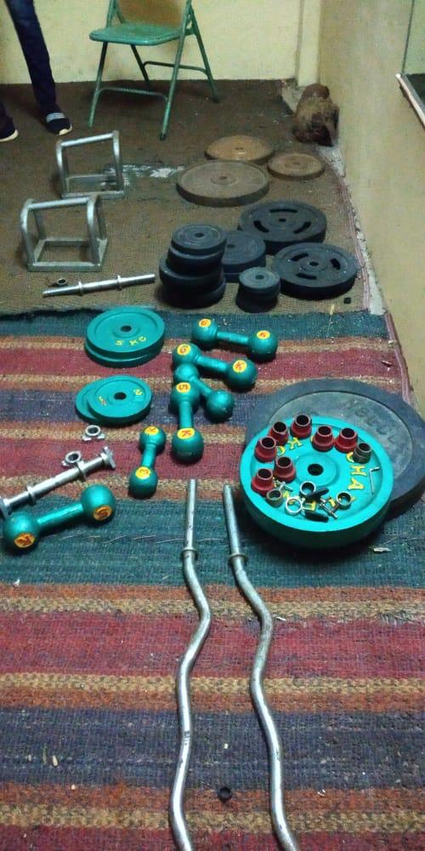
Some gadgets used in the Gymnasium
The well equipped multi gym provides students the opportunity to build their stamina to be better able to cope with the rigours of college life, channelize their energies in a healthy way and also hone their physique. Access to the gym is availed to both male and female students at different time slots. The facilities of the Gymnasium are also open to the teaching and non teaching staff of the college.
Work out by the students in the Gymnasium
YOGA
To maintain physical, mental and spiritual fitness and to follow the footsteps of our Yogees and Rishees, yoga exercise is being given to the students by well-trained Yoga masters. Yoga classes are arranged during the week ends and are well monitored by the health club members. Many of the teaching staff of the college is well acquainted with the Yoga steps and hence they also conduct effective Yoga sessions for the students.
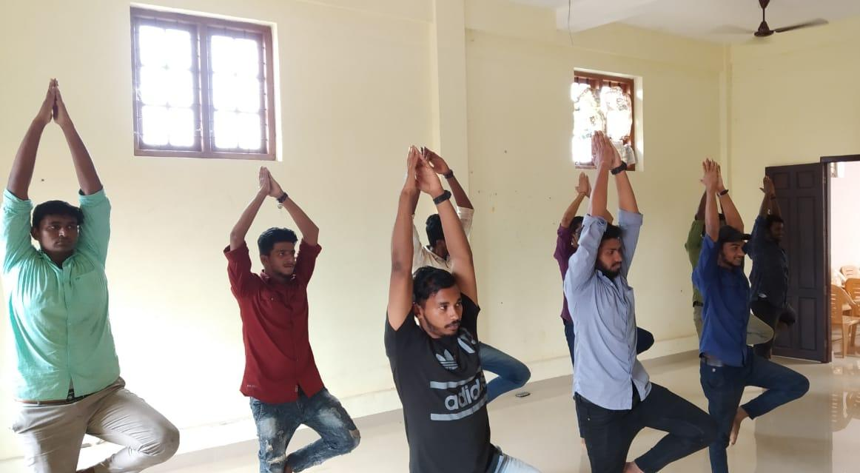
Students practising Yoga exercise
Yoga helps to clear the mind, which can give students a break from the constant social atmosphere of college. Practicing to get to a quiet mindspace can make it easier to concentrate when reading, studying and sitting through lectures. This helps the students to keep themselves away from stress and strain in life and to contemplate and concentrate.
CYCLING EXERCISE PROGRAMME
One of the attractive ventures of the health club during this academic year was the introduction of a Cycling exercise programme for women. It was inaugurated by the Hon. MLA Smt. P. Aisha Potti followed by the free distribution of cycles to the college. The first cycling ride was done by the College Principal Dr. Suman Alexander which really motivated and inspired the whole women community.
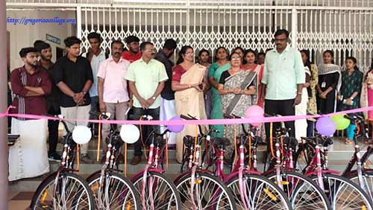
Inauguration of the cycling programme and Distribution of cycles by the Hon. MLA, Smt . P. Aisha Potti
The Cycling exercise was carried out by the women students during the evening sessions after the College hours and during holidays under the monitoring of the health club members. As far as women students are concerned, cycling is an easily accessible activity that can reinforce a sense of self-worth and pride in keeping their body active. It also offers the opportunity to enjoy some quality ‘me time’, away from domestic duties, and can help reduce stress, anxiety and depression.
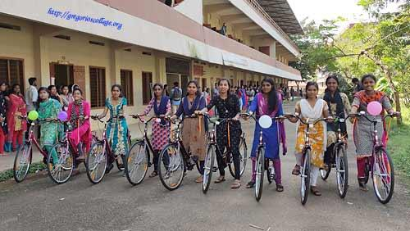
Students getting ready for the first Cycling exercise

HEALTH CARD
The health club also became successful in keeping a record of the health details of the students by introducing a health card for the ongoing students of this academic year. With the help of the health card, a primary level knowledge regarding the health status of each student can be revealed. Health card information helps to provide timeliness and accurate health care services during emergency situations. It can further be used as a source for monitoring and evaluating the overall health profile of the college. It is also hopefully expected that this venture can be continued in the upcoming academic year.

Health Club Co-ordinators:
DR. ASWATHY AROMAL S.
REJANI V. KOSHY

